**RESTFUL APIs Samuel Okwalinga**

**Definitions:**

An API (Application Programming Interface) for a website is basically code that allows two software programs to communicate with each other for instance communication between, a server and a database, server and a browser or the operation system and another application. Some popular examples of web service APIs include SOAP, XML-RPC, JSON-RPC and REST APIs.[1]

REST[2] (REpresentational State Transfer). First introduced by Roy Fielding in 2000, it is web standards based architecture and uses HTTP (Protocol) requests to access and use data.

RESTful web services are a collection of open protocols and standards used for exchanging data between applications or systems on the internet. It is these services that allow interoperability between software applications written in various programming languages on the web (e.g., communication between Java and Python, or Windows and Linux applications).

**REST structure**

In REST, every component is a resource which can be accessed by a common interface using HTTP standard methods. Therefore, a REST Server simply provides access to resources and REST client accesses and modifies the resources using HTTP protocol.

Resources are identified by URIs (Universal Resource Identifiers)/ global IDs. In REST, these resources can be represented by a text, JSON (most popular), XML.

Common HTTP methods used in REST based architecture include GET, PUT, POST and DELETE which are essentially reading, updating, creating and deleting (CRUD) operations.

**How Rest API works**

A RESTful API works by breaking down a transaction to create a series of small modules. Each module addresses an underlying part of the transaction for instance GETting (READ) data, parsing/rendering that data. REST leverages upon Node.js single threaded and asynchronous model in that all calls are stateless nothing can be retained by the RESTful service between executions thus allowing for free resources to be reusable in between calls. This makes it a preferred choice for data intensive applications such as on the cloud and the web where several I/O operations are performed.

**Data formats supported by the REST API**

application/json, application/xml, application/x-wbe+xml, application/x-www-form-urlencoded and multipart/form-data.

**Disadvantages of using REST API[3]**

* Endpoint consistency: paths of endpoints should be consistent by following common web standards, which may be difficult to manage.
* Long response times and too much data: the amount of returned resources can increase in size in time, adding to increased load and response times.
* Navigation paths and user input locations: because REST uses URL paths for input parameters, determining URL spaces can be challenging.
* Security: lots of aspects such as HTTPS, validating URLs, blocking unexpectedly large payloads, logging requests, investigating failures and authentication concerns.

**JSON (Javascript Object Notation)**

JSON is an open standard file format, and light-weight data interchange format, that uses human-readable text to store and transmit data objects consisting of attribute–value pairs and array data types[4]. JSON is used in a many applications such as on the server-side for serving files between a client (browser) and web server e.g. sending, receiving and storing data instead of using XML in AJAX systems.

JSON is not a programming language but it uses JavaScript syntax and its format is text only. Because text can be read and used as a data format by any programming language, JSON format is often used by other programming languages since text can easily be sent to and from a server[5].

The JSON format was originally specified by Douglas Crockford in the early 2000s after which it was first standardized in 2013 as ECMA-404. The current version - RFC 8259 was published in 2017.[6]

JSON is built on two structures[7]:

1. A collection of name/value pairs. In various languages, this can be an object, record, struct, dictionary, hash table, keyed list, or associative array.
2. An ordered list of values. In most languages, this can be an array, vector, list, or sequence.

**TYPICAL JSON SYNTAX**

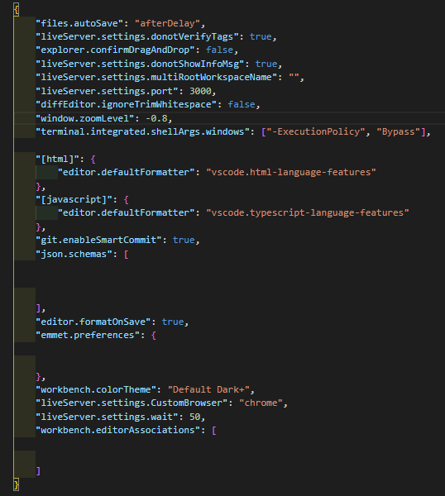

**KEY TERMS**

|  |  |
| --- | --- |
| APIs[8] | Application Programming Interface – a computing interface which defines interactions between multiple software intermediaries. Defines the kinds of calls or requests that can be made, how to make them, the data formats that should be used, the conventions to follow among others. |
| SOAP (Simple Object Access Protocol)[9] | This protocol uses XML as a format to transfer data. It also uses Web Services Definition Language (WSDL), in a machine-readable document to publish a definition of its interface. |
| XML-RPC | This protocol is older than SOAP and it uses a specific XML format to transfer data compared to SOAP that uses a proprietary XML format. |
| JSON-RPC | This protocol is similar to XML-RPC but instead of using XML format to transfer data, it uses JSON. |
| Web architecture[10] | The conceptual structure of the World Wide Web e.g. Client-server model, three-tier model Service-oriented architectures (SOA) |
| Resources[11] | Anything that can be obtained from the World Wide Web e.g. web pages, e-mail, information from databases, and web services. |
| URI | Uniform Resource Identifier – identify resources on the web. Similar to URLs. |
| Global ID | Unique identification of resources on the web. |
| JSON | Javascript Object Notation - used for transmitting data in web applications (e.g., sending some data from the server to the client, so it can be displayed on a web page, or vice versa) |
| XML | Extensible Markup Language - defines a set of rules for encoding documents in a format that is both human-readable and machine-readable. |
| Web Service | A collection of open protocols and standards used for exchanging data between applications or systems on the web. e.g. REST, SOAP (Simple Object Access Protocol). |

1. https://rapidapi.com/blog/types-of-apis/
2. https://www.tutorialspoint.com/nodejs/nodejs_restful_api.htm
3. https://searchapparchitecture.techtarget.com/definition/RESTful-API#:~:text=A%20RESTful%20API%20is%20an,deleting%20of%20operations%20concerning%20resources.
4. “Standard ECMA-404 - The JSON Data Interchange Syntax”. Ecma International. December 2017. p. 1.
5. https://www.w3schools.com/js/js_json_intro.asp
6. “Standard ECMA-404 - The JSON Data Interchange Syntax”. Ecma International. December 2017. p. 1.
7. https://www.json.org/json-en.html
8. Fisher, Sharon (1989). ["OS/2 EE to Get 3270 Interface Early"](https://books.google.com/books?id=YToEAAAAMBAJ&q=application+programming+interface&pg=PA6). *Google Books*.
9. https://rapidapi.com/blog/types-of-apis/
10. https://en.ryte.com/wiki/Web_Architecture
11. Lavoie, B. & Nielsen, F. (1999). "Web Characterization Terminology & Definitions Sheet". W3C